Edgy Activity - Creating Networks in Edgy
CS4S Maths - Networks Workshop

Introduction
You will learn about the following Networks concepts in this activity:
- Graphs and Subgraphs
- Complete Simple Graphs
- Random Graphs
- Cyclic Graphs
- Connected Graphs
This activity will also involve applying some of the concepts that you learned about in the Coding in Snap! Activity, including:
- Sequencing
- Repetition
- Variables
- Functions
- Branching
- Lists
You will also learn about Stacks and Dictionaries, which are Collections of items that are similar to Lists.

The Project
The project that you make in this activity will involve creating Random Graphs and running algorithms on those Graphs. There are two main algorithms that you will implement in this activity, which are algorithms for finding whether a Sub-Graph with edges of a certain colour:
- is connected
- contains a cycle
These algorithms will also be used in the activity where you write other algorithms in Edgy to find a Graph's Minimum Spanning Tree. The main aim of this activity is to familiarise you with the Edgy interface and show you some different algorithms that can be applied to Graphs in Edgy.
While we will only look at fairly small Graphs of 26 nodes or less, it is possible to create graphs that have more than 100 nodes in Edgy. The default limit on the number of nodes is 150, but this can be increased up to 1,000 nodes by using the maximum visible nodes option. The real power of Graph algorithms is the ability for analysing and solving problems that involve large networks that have many nodes and edges. We will look at some examples of applying Networks to real-world problems in the workshop and also show you some example datasets, such as social network graphs and large road networks, that can be downloaded from websites like: The Koblenz Network Collection and the Network Repository. It is possible to use these datasets in Edgy, provided that they are in the correct format.

Edgy vs Snap!
Edgy is a modification of the Snap! programming language that was created by researchers at the University of Melbourne and Monash University. Edgy has been used in the new VCE (Victorian Certificate of Education) Algorithmics subject, which involves the teaching of algorithm design and analysis. We have included some links to websites that explain Edgy in more detail on this session's page on the workshop website.
You may notice that Edgy, unlike Snap!, does not have the following categories of blocks:
- Motion
- Sensing
Instead, Edgy has four categories of blocks that Snap! does not have:
- Network
- Nodes
- Edges
- Collections
Edgy does not really have Sprites, unlike Snap!. Instead of Sprites, one Graph is displayed on the Stage and this Graph is manipulated through the blocks in the Scripts Area. Currently, it is not possible to create and interact with multiple Graphs in Edgy.
Before moving onto the next section of the activity, you may want to explore some of the blocks in the different sections and see how they affect the graph that is created in Edgy. If anything in Edgy does not work as you would expect or you receive error messages when clicking the different blocks, please let us know.

Creating Graphs on the Stage
In Edgy, you can create graphs by using Code blocks, but you can also add edges and nodes by using the Stage menu. Right-click on the Stage area and a menu will appear.
You can create a Graph by using the add node and add edge options. For example, you could add the following nodes and edges to create a simple road network:
- node: Newcastle
- node: Maitland
- node: Cessnock
- edge with Start node: Newcastle and End node: Maitland
- edge with Start node: Maitland and End node: Cessnock
The resulting Graph will look like the Graph in the image shown below:
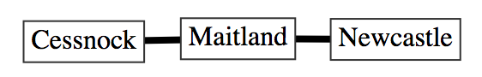
Note that, if you add an edge where the nodes are not in the Graph - for example: an edge that connects the node Swansea to a node called Sydney - those nodes will be added to the Graph. You can also adjust the colours, scales and shapes of nodes and edges, or even delete nodes and edges, by right clicking on them and using the menu.
You are also able to import files, that are in certain formats (such as the DOT format), to create Graphs in Edgy. To see how this works, please download the Example Food Web Network DOT File from this session's page on the workshop website and save it somewhere easy to find (such as the Desktop). If you would like to see how the DOT file is structured, the file can be opened in text-editor programs like Notepad or TextEdit. Next, right click on the Stage, select the import graph from file option and open the DOT file that you downloaded from the workshop website. A Graph, which is a food web, will appear on the Stage. The layout of the Graph is automatic and may also be hard to read because the nodes and edges bunch together, but you can adjust the layout by selecting the use manual layout and dragging the nodes around the Stage. When an animal/plant has an edge pointing to another animal, this means that the animal/plant is consumed by that other animal. For example, the Frog node has an edge pointing to the Python node, because Pythons eat Frogs.
This feature for importing Graphs can be very useful for analysing interesting networks (such as the social networks mentioned in the The Project section above) into Edgy. In this activity, we will focus on creating Graphs using blocks instead, which we will begin to look at in the next section.

Sequencing in Edgy

Adding Reset Code
Before you create Graphs, you should create the following stack of blocks:
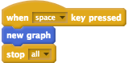
These blocks will allow you to press the space bar to erase the Graph that is currently on the Stage and stop all blocks from running.

Adding Nodes
Now, we will create a Graph by using blocks. Add the following blocks to the Scripts area in Edgy:
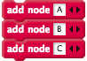
Once you click the stack of blocks, three nodes (named A, B and C) will appear on the Stage. You may notice that these nodes all appear almost instantly. This is because we are not telling the program to wait between the commands. This is similar to how a Sprite in Snap!, that is told to move with multiple move blocks and no wait blocks, will only make one movement.
We could add wait blocks to introduce slight pauses between adding each of the nodes. Clear the Graph by pressing the space bar and change the stack of blocks to look like those below:
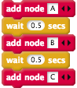

Adding Edges
This activity will be focused on undirected Graphs, which are Graphs that have edges with no direction.
Now, add the following blocks to your program after the blocks that add the nodes:
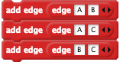
Like the example with the nodes above, these edges appear almost instantly. You may want to introduce some pauses between the adding of edges as well. Clear the Graph again by pressing the space bar and change your blocks to look those shown in the image below:
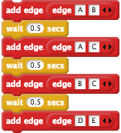
You may notice that when the last edge (D connected to E) is added to the Graph, the D and E nodes are added to the Graph as well.

Attributes of Nodes and Edges
Edgy allows you to change different attributes of nodes and edges, such as: nodes' shapes or edges' colours. You can use blocks like the set attribute of node and set attribute of edge blocks to change nodes' and edges' attributes.
For example, add the following block after your stack of blocks, clear the Graph and click the stack of blocks.
After running the stack of blocks, the A node should now be shaped like a circle. Next, add the following block, clear the Graph and click the stack of blocks.
The edge that connects D and E should now be coloured red. In the next section, we will use Repetition to create larger Graphs with a smaller amount of blocks.

Check Your Understanding
Now that we are the end of the Sequencing in Edgy section, try and answer the questions below. If you need any clarification about these questions, please let us to know. The solutions to these questions are also available on the workshop website.

Sequencing: Exercise 1
A student creates the following stack of blocks:
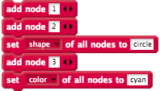
The student expect that, after clicking all of the blocks, all of the nodes will be shaped like circles, but only two of them are. Why are only two of the nodes shaped like circles and how could the students change the stack of blocks above so that all of the nodes are shaped like circles?

Sequencing: Exercise 2
Read the blocks below and, without using Edgy, draw what the resulting Graph would look like.
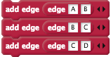
Is the Graph created by the blocks above connected and/or cyclic?

Repetition in Edgy

Adding Nodes in a Loop
In this section, you will learn how to create Graphs in Edgy with Repetition. You can move the blocks that you used in the last section away from the other blocks or delete them, as we will be building a different stack of blocks for the rest of the activity.
Create the following stack of blocks, which will create a Graph with 5 nodes and no edges.
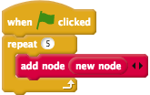
The new node will add a node that is labelled with the number that is 1 more than the largest label in the Graph. So, for example, after running the stack of blocks above and then clicking the new node block in the Nodes section, a node with the label 6 will appear in the Graph.
We have not included wait blocks in the rest of the activity's examples, to keep these examples concise. However, you can add these if you would like to have pauses between adding nodes and/or edges.
Instead of using numbers for our nodes' labels, we are going to use letters. The Unicode format can be used to represent letters with numbers. Each number in the Unicode format corresponds to a letter, for example, the number 65 represents the upper-case A and the number 97 represents the lower-case a. We will create nodes with a loop using the range of Unicode numbers 65 - 90, which are the 26 capital letters of the alphabet.
We will need to use a variable to keep track of the Unicode number in our loop for creating these nodes, which we will call i. To create the i variable, follow these steps:
- Go to the Variables blocks section of the Blocks Palette.
- Click the Make a Variable button
- Name the variable i
- Tick the For this sprite only checkbox
- Click the OK button
Next, change your stack of blocks so that they look like the image below:
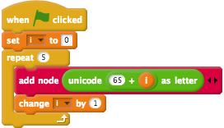
In the blocks above we create a graph with 5 nodes with labels, by using Unicode codes (which are in the brackets following the letters): A (65), B (66), C (67), D (68) and E (69).

Adding Edges in a Loop
Next, we will use nested repetition to create edges in our Graph. In a previous workshop activity you looked at adjacency matrices, which can be used to represent Graphs.
An example adjacency matrix is shown in the image below.
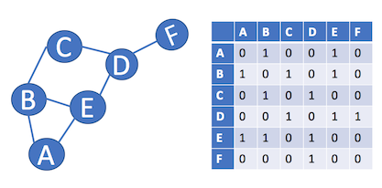
We are going to make a stack of blocks that will connect all of the nodes to every other node with an edge. To do this, we will have to repeat the add edge command for every column and row of the adjacency matrix.
We will use two variables in the nested loop for adding the edges. We already have a variable called i, but you will need to create another variable called j by following these steps:
- Go to the Variables blocks section of the Blocks Palette.
- Click the Make a Variable button
- Name the variable j
- Tick the For this sprite only checkbox
- Click the OK button
Next, add the following blocks to the bottom of your stack of blocks that add the nodes.
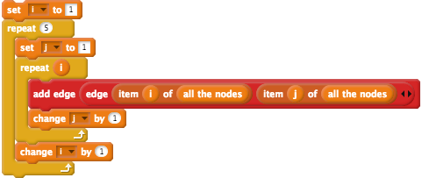
Note that the i and j variables both start at 1. The item of all the nodes block will give us the appropriate node for the given number - item 1 of all the nodes is A, item 2 of all the nodes is B and so on. If we created the adjacency matrix for the Graph created by these blocks above, it would look like the matrix below.
 | A | B | C | D | E
A | 1 | 1 | 1 | 1 | 1
B | 1 | 1 | 1 | 1 | 1
C | 1 | 1 | 1 | 1 | 1
D | 1 | 1 | 1 | 1 | 1
E | 1 | 1 | 1 | 1 | 1
You may recall that adjacency matrices for undirected Graphs are symmetrical. For example, if we revisit the Graph and adjacency matrix shown before, you can see that the green and orange cells in the matrix are the same, just mirrored.
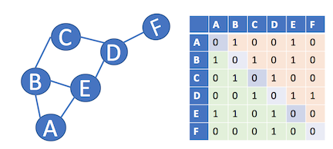
So, if we have the adjacency matrix for our Graph in Edgy, which is shown below, then we can just add edges for the cells in green and we will still end up with the same resulting Graph.
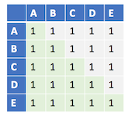
Consequently, we can change the 5 in the inner repeat block to the variable i, as shown in the image below, and the resulting Graph will be the same as before:

Making a Simple Complete Graph
Graphs that have no loop edges (edges that connect a node to itself) and that don't have more than one edge between each pair of nodes are called simple Graphs. The Graph that we have created is not a simple Graph because it does contain loop edges. We can use branching to stop the blocks from drawing the loop edges, by not adding an edge to a Graph when the i and j variables are the same. So, for example, when i and j are both 3, our Code will make sure that an edge that connects the node C to itself will not be added to the Graph.
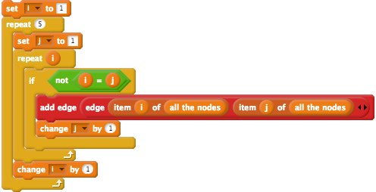
Not only is the resulting Graph a simple Graph, it is also a complete Graph. A complete graph is a Graph where there is an edge between every node, which means every possible edge in the Graph is present. Complete graphs are usually denoted by Kn, where n is the number of nodes in the Graph. We have created the K5 Graph with the blocks above, but we could adjust the number of nodes. For example, you could create K9 by changing the number 5 in the 2 repeat blocks to 9 and recreating the Graph.

Check Your Understanding
Now that we are the end of the Repetition in Edgy section, try and answer the questions below. If you need any clarification about these questions, please let us to know. The solutions to these questions are also available on the workshop website.

Repetition: Exercise 1
After the stack of blocks below are clicked, how many nodes will be in the graph?
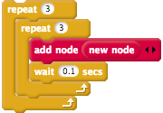

Repetition: Exercise 2
A student has added 10 nodes to a Graph, has the following stack of blocks and is hoping that the blocks will draw a complete simple Graph K10.
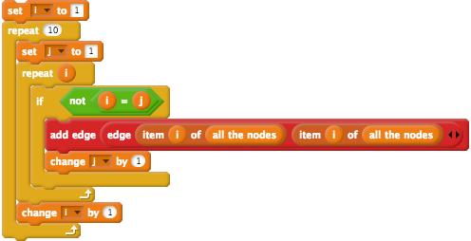
However, after running the blocks the resulting graph is not complete. The graph has 10 nodes but they are not all connected. The student has made a mistake in their Code, what is it?

Randomisation in Edgy

Creating Random Graphs
Now, we are going to modify the program to create random Graphs. There are a few different ways of creating random Graphs but the approach we will use in this activity involves using the Erdős–Rényi model of random Graphs. We have included some links which explain random Graphs in more detail, and gives some examples of where they are applied, on the workshop website.
Random Graphs in the Erdős–Rényi model are denoted by G(n,p), where n is the number of nodes in the Graph and where each possible edge in the Graph has p probability of being present in the Graph. So, for example, if there is a random graph with two nodes: A and B and p of 25%, then there will be a 25% chance that there will be an edge between A and B.
Before we add randomisation to the blocks, you will need to create a number of nodes variable by following these steps.
- Go to the Variables blocks section of the Blocks Palette.
- Click the Make a Variable button
- Name the variable number of nodes
- Tick the For this sprite only checkbox
- Click the OK button
After creating that variable, replace the 5s in the repeat blocks with the number of nodes variable. Next, repeat the same steps above for another variable called probability.
You should also add set variable blocks, just after the when green flag clicked block, that set the value of the number of nodes variable to a number (such as 5) and the probability variable to a number (such as 25). Next, we will use nested branching and randomisation to create random graphs. The p (the probability of the edges being in the Graph) will be a number between 1 and 100, which will represent the percentage of likelihood that an edge is added to the Graph.
Now, we will change the loop that creates all the edges to look like the blocks below.
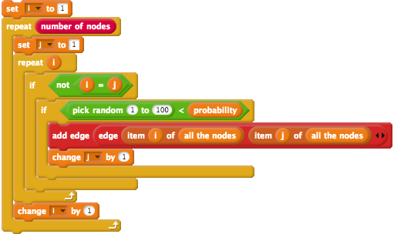
So for example, for when the probability variable is 25 (a probability of 25%), a number between 1 and 100 is chosen randomly. If the random number is less than the probability (for example: if the random number is 22), then the appropriate edge will be added to the Graph.
You could try changing the values of the probability and number of nodes variable and see the resulting Graphs. What happens when the probability variable is 0 and what happens when the probability variable is 100? Why is that? Are the Graphs that generated cyclic and/or connected? Are the Graphs created with a higher probability more likely to be connected and/or cyclic?

Setting Random Edge Weights
Next, we will add random weights to all of the edges in the random Graphs we create.
Edge weights usually represent a cost. For example, in a road network the edge weigts could be the distance between two cities/landmarks. In Edgy we can assign edge weights by setting the label attribute of an edge.
Firstly, create another variable called new edge by following these next steps.
- Go to the Variables blocks section of the Blocks Palette.
- Click the Make a Variable button
- Name the variable new edge
- Tick the For this sprite only checkbox
- Click the OK button
You will use the new edge variable when setting the edges' weights. To set the edges weights to random numbers, you can change your blocks to look like the following stack of blocks.
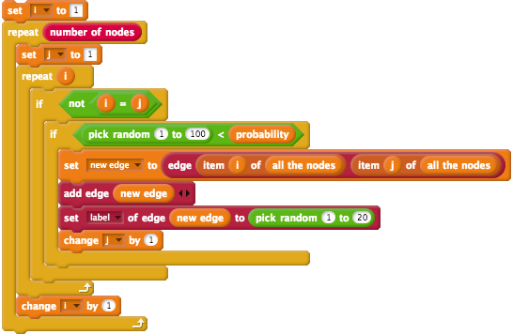

Colouring Edges
Now, we will change the colour of the edges. If the edge has a weight larger than 10, we will make it red. If the edge has a weight less than 10, we will make it green.
To do this, add the following stack of blocks after the set label of edge block (where a random weight is added to an edge), in the inner if block.
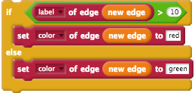
Now, when you create a new random Graph, you will notice that the edges are now coloured red or green, depending on their weight.

Creating a Random Graph Block
In the next section, you will learn how to implement some algorithms for finding whether a Graph is cyclic and/or connected. Before moving onto the next section, however, the blocks that you have created should be placed into a custom block called create random graph.
To create the create random graph block, right-click anywhere on the Scripts Area (except for the stacks of blocks) and click the make a block... option in the menu. After selecting the make a block... option from the menu, a popup window titled Make a block will appear. We want the create random graph block to appear in the Networks section of the Blocks Palette, so you should select the Networks option in the Make a block window. You will also have to enter the block name (create random graph) and make sure that the Command block is selected. The form in the Make a block popup should look like the image below:
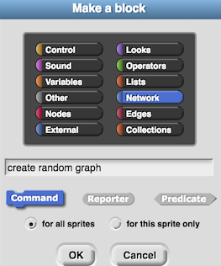
After clicking the OK button, the Block Editor will open. The Block Editor window is where you will add Code blocks to define the actions that your new block will perform. You can re-open this window at any time by right-clicking on one of the blocks you have made and clicking the edit... option.
The create random graph block will have two inputs, which will both be Numbers, called: number of nodes and probability.
To add an input to the block:
- Click the + next to graph in the block name (as highlighted by the red circle in the image below)
- When the Create input name window appears, put the name of the input (which we will call number of nodes) in the textbox, as shown in the image below.
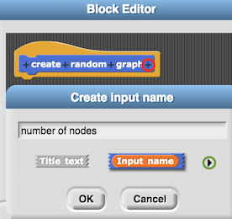
Before you click OK, click the right arrow (highlighted by the green circle in the image above) and you will see options appear for choosing the type of variable that the input is (such as: Number, Boolean and List). We want the number of nodes to be a Number, so select the Number option from these options and click OK. The number of nodes input should appear in an orange oval (like a variable) in the block name and there should also be a # added to the end (to signify that the input is a number).
Repeat the same steps above for creating an input to the create random graph block called probability.
The blocks from the set i to 0 block at the top of the stack, to the bottom of the stack, should be dragged under the create random graph block in the Block Editor.
After creating this block, you will want to place the create random graph after the set probability to block. Next, you should use the number of nodes and probability variables as input to the create random graph block. Now, your stack of blocks should now look like the stack of blocks shown below.
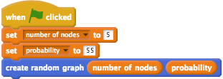
You now have a Function for creating random Graphs, that you will be able to use for testing the algorithms you implement in the next sections. Before moving on to the next section, you may want to try creating random Graphs with different values for the number of nodes and probability inputs and see the different Graphs that are created.

Check Your Understanding
Now that we are the end of the Randomisation in Edgy section, try and answer the questions below. If you need any clarification about these questions, please let us to know. The solutions to these questions are also available on the workshop website.

Random Graphs: Exercise 1
You create a random Graph and the result is pictured below.
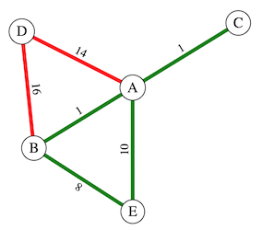
This Graph contains two Sub-Graphs: one which contains all of the nodes and only the red-coloured edges (GR), and one that also contains all of the nodes and only the green-coloured edges (GG).
Is GR connected and/or cyclic?
Is GG connected and/or cyclic?

Random Graphs: Exercise 2
You create another random Graph and the result is pictured below.
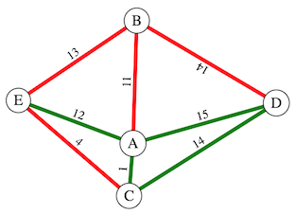
This Graph contains two Sub-Graphs: one which contains all of the nodes and only the red-coloured edges (GR), and one that also contains all of the nodes and only the green-coloured edges (GG).
Is GR connected and/or cyclic?
Is GG connected and/or cyclic?

Connected Graphs

Finding a Connected Graph
In the previous Check Your Understanding exercises, you could tell whether a Graph was connected by inspection. However, would you be able to tell if a Graph with hundreds of nodes and edges was connected, just by looking at it? For example, the police might investigate whether a group of 200 criminals are connected in some way. The police could analyse the criminals' phone records to create edges in the Graph where two criminals (represented by nodes) had spoken on the phone to each other. Rather than inspecting the Graph to tell whether the network of criminals is connected, the police could use an algorithm to find this out. If the police find that the Network of criminals is connected, they could conclude that it is likely that the criminals all belong to the same criminal organisation.
You will learn how to implement an algorithm for finding whether or not a Graph is connected in this activity. Edgy already has a block for finding the connectedness of a Graph called is connected. However, the block that we make in this activity will allow us to find whether a Sub-Graph with edges of a certain colour is connected, which the is connected block in Edgy does not do.
You may recall that a Graph is connected if there is at least one path from every node to every other node in the Graph. So, if we start at some node in a connected Graph, follow its edges to its neighbours, then follow the neighbours' edges to their neighbours, and so on, we should visit every node in the Graph. However, if we follow all the edges from any node in the Graph and find that, after following all of the edges, some of the other nodes are not visited - then the Graph is not connected.

Depth-First Search
A common approach for finding whether a Graph is connected is using a depth-first search. A depth-first search generally involves the following steps:
- Choose a start node
- Look at all of the node's neighbours
- Mark all of the neighbours that have not been visited yet as to visit
- If there are some nodes left to visit, take the last node marked as to visit and go to Step 2. If there are no nodes left to visit, you are finished the search.

To implement a depth-first search in Edgy we need to use a Collection called a Stack. A Stack is similar to a List, but, unlike a List, a Stack only has three main ways of accessing and modifying its items. You can imagine a Stack to be like a deck of cards, that you can only perform the following actions on:
- push: put an item on the front of the Collection - you could think of this as placing a card on the top of a deck.
- peek: look at the first item in the Collection (this is called the top of stack block in Edgy) - you could think of this as having a look at the top card on a deck and then putting it back on the top of the deck.
- pop: removing the first item in the Collection - you could think of this as taking the top card on a deck and then discarding the card.
For example, part of the depth-first search algorithm will involve pushing a node's neighbours to a Stack. The Stack will be a variable that we will call: to visit. To create the to visit variable, you can follow the steps described below.
- Go to the Variables blocks section of the Blocks Palette.
- Click the Make a Variable button
- Name the variable to visit
- Tick the For this sprite only checkbox
- Click the OK button
Now, we will add some blocks to add the neighbours of our first node A to the to visit Stack, which will go after the create random graph block you created in the previous section. In this activity, we will use some blocks that are not initially visible in Snap! and Edgy. To show these blocks, you will have to click the menu at the top of the screen that looks like a blank piece of paper (the File menu) and then click the Import tools option. After clicking the Import tools option, you may notice that there are some new blocks in the Block Palette. For example, in the Variables section you may notice that there is now an empty? block.
When a depth-first search is performed on a Graph, a start node node is usually chosen randomly and marked as to visit. In the depth-first search we create in Edgy, we will push the first of our nodes (A) onto a Stack (the to visit variable). These steps can be seen in the first two blocks in the stack of blocks below.
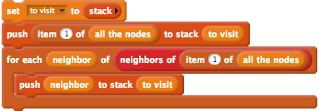
The first block above sets the to visit variable to an empty Stack and the second block pushes the first node in the Graph onto to visit, which places that node (A) on the top of the Stack. You can rename item by double-clicking on the orange item bubble and typing in neighbor instead. After running your program, the to visit Stage monitor should have the neighours of the node A in it.
In the depth-first search, we will use another variable, called visited, which will be a List of nodes. When the search visits a node that has not been visited by the search before, that node will be added to the visited list. Consequently, the visited List will be empty to begin with, as the search will not have visited any nodes. To create the visited variable, follow the steps above for creating the to visit variable, but use variable name: visited* instead.
To demonstrate how we will add nodes to the visited List, change your stack of blocks so that they look those in the image shown below. Note that the stack of blocks below will be modified extensively for the depth-first search, these are mainly used to demonstrate how we will add items to, and remove items from, the to visit *Stack.
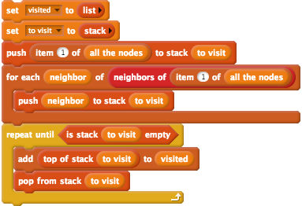
After running the stack of blocks above, you may notice that the items in the visited List are now in reverse order to what they were in the to visit Stack. In the repeat until block, the top node on the to visit Stack is taken off the top, put at the end of the visited List and then put the node back on the top of the Stack Then, the pop action is performed on the to visit Stack, which removes the top node from the Stack. These two actions are repeated until all of the items in the to visit Stack are removed (when it is empty).
You will have to rearrange the blocks above, so that all of the connected nodes are added to the to visit Stack and the visited List. But first, you will need to create another variable named current node, which you can do by following the steps for creating the to visit variable, but using the variable name visited instead. This variable will be used to keep track of the node that is currently being visited, when we implement the depth-first search algorithm. Note that you will not want to click on these blocks yet, we need to add some extra blocks in the next step first.
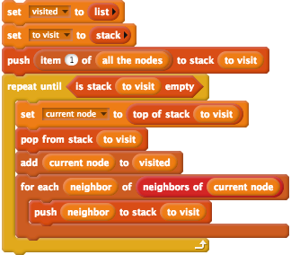
In the blocks above, the for each block from the previous example has been placed inside the repeat until block. The current node variable has also been added to the blocks, to keep track of the node that is currently at the top of the to visit Stack. However, the blocks above will not work correctly - as they do not include any blocks to check whether the current node or neighbor nodes have already been visited. If a node has already been visited, the depth-first search does not need to search it again and consequently, you will need to use Branching to check whether a node has already been visited. To do this, you will need to create two if blocks, which are shown in the image below. The first if block will "wrap around" the last three blocks (add,for each and push to stack) and will check if the current node has already been visited. The second if block will be placed inside the for each block and will check if the current node's neighbours have already been visited. Consequently, only unvisited neighbours will be added to the to visit Stack.
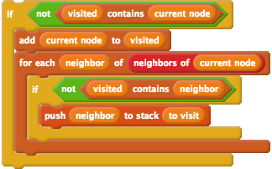
The if block above will check if the visited List does not contain the node from the top of the to visit Stack, and if so, the algorithm will add that node to the visited List and push all of that node's unvivisted neighbours to the to visit Stack.
After adding the if blocks, you may want to create some different random Graphs and then run the blocks above. What do you notice about the items in the visited List for the Graphs that are connected, compared to those that are not connected?

Checking for Connectedness
You may have noticed that when Graphs are connected, the visited List will contain all of the labels of the nodes in the Graph. Therefore, we will be able to tell when the Graph is connected, when the length of the visited List is the same as the number of nodes in the Graph.
In the next step, we are going to make our blocks report when the Graph is connected. Add the following blocks to the bottom of your stack of blocks, after the repeat until block:
Now, if you click the stack of blocks, a speech bubble will appear with true (if the Graph is connected) or false (if the Graph is not connected). Try some different random Graphs, of larger size (for example: 20+ nodes), and see if the reported result (true or false) matches what you expect.
Currently, the blocks we have report whether the Graph is connected, regardless of the colour of the edges. In the next steps, you will add blocks to report whether Sub-Graphs with edges of certain colours are connected.

Subgraphs with Coloured Edges
You may recall that, as explained in the Colouring Edges sub-section of the Randomisation in Edgy section, there are blocks in Edgy that report attributes of edges. As we are implementing a depth-first search for Sub-Graphs with edges of a certain colour, this means that we only want to visit neighbours of the current node when the edge between them is that certain colour. To do this, you need to change the for each part of the stack of blocks to look like the blocks in the image below, which includes a check for the appropriate colour (which is green in the example below).
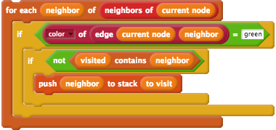
At the moment, the blocks above only work for edges coloured green but in the next steps we will put these blocks into a Function, which will take any colour name as input.

Creating a Custom Block
Now, we are going to create a block for checking whether a Sub-Graph with edges of a certain colour is connected and name it: is subgraph of colour edges connected. Before making this block, duplicate all of the blocks from after the create random graph by right clicking on the stack of blocks and clicking duplicate. Place this duplicated stack away from, and seperate to, your other blocks. You can keep the duplicated and separate stack as it is for now, we will modify that stack in the next section of the activity.
To create the is subgraph of colour edges connected block, right-click anywhere on the Scripts Area (except for the stacks of blocks) and click the make a block... option in the menu. After selecting the make a block... option from the menu, a popup window titled Make a block will appear. We want the is subgraph of colour edges connected block to appear in the Networks section of the Blocks Palette, so you should select the Networks option in the Make a block window. You will also have to enter the block name (is subgraph of colour edges connected). The block that we make in this step will report one of two Boolean values (true or false), so it is appropriate to make it a Predicate Function by selecting the Predicate option. The form in the Make a block popup should look like the image below:
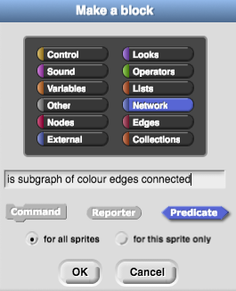
After clicking the OK button, the Block Editor will open. You can delete the report block that is after the is subgraph of colour edges connected hat block, because we will add our own report block in the Block Editor. Take all of the blocks after the create random graph and drag them under the is subgraph of colour edges connected hat block in the Block Editor.
The is subgraph of colour edges connected block will have one input, which will be called colour. The name colour is already in the name of the block but we can make this an input by following these steps in the Block Editor:
- Click the colour text in the block name, as highlighted by the red circle in the image below
- Select the input name option, as highlighted by the green circle in the image below
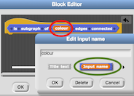
Next, we need to use the colour input variable in our stack of blocks when checking the colour of the edge between the current node and the neighbour. To do this, replace the text green with the input variable in the blocks that are in the is subgraph of colour edges connected block. That part of the stack should look like the image below:
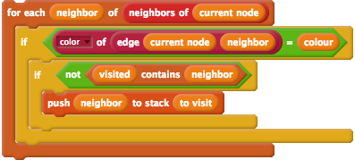
Now, you can add the is subgraph of coloured edges connected after the create random graph block. You can put your custom block inside a say block, so that the result of the block is shown on the Stage. After adding these two blocks to your stack, the stack following the when green flag clicked block should look like the below image:
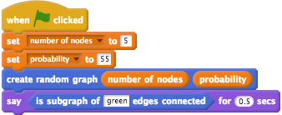
You have now successfully created the block for checking whether a Sub-Graph of certain coloured edges is connected. In the next section, you will extend the depth-first search algorithm, to check whether a Sub-Graph is cyclic.

Check Your Understanding
Now that we are the end of the Connected Graphs section, try and answer the question below. If you need any clarification about this question, please let us to know. The solutions to this question is also available on the workshop website.

Connected Graphs: Exercise 1
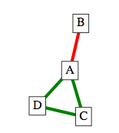
When we use our is subgraph of coloured edges connected block for finding whether the Sub-Graph of green edges and all nodes is connected, does it matter which node the block starts from? For example, will the result of the block be false if it starts from node B?

Cyclic Graphs

Finding a Cyclic Graph
In the Graphs we have looked at so far, it can be easy to tell whether a Graph is cyclic by simply looking at it. But, for Graphs of larger sizes, programs have to be written to find whether a Graph is cyclic.
You may recall that Trees are acyclic and consequently algorithms for finding cycles are used in cases where Networks have to be Trees. Consequently, algorithms for finding Trees in a Graph, such as the Kruskal's algorithm you will learn how to implement later, often include steps that check whether a Graph is cyclic.
One method of checking for cycles in a Graph is explained in the next steps.

Back Edges
One way to find whether a Graph is cyclic, is to find out whether there is a type of edge, called a back edge, in the Graph. In this activity, you will extend the depth-first search algorithm to check whether the Graph contains a back edge.
When we are performing the depth-first search and visiting the current node, we check for back edges. A back edge is an edge that connects one of the current node's neighours to one of the current node's ancestors. An example of a back edge, which is coloured red, is shown in the image below.
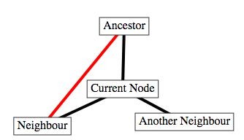
In the example above, there are three edges that form a cycle in the Graph: (Ancestor, Current Node), (Current Node, Neighbour) and (Neigbour, Ancestor). The back edge that has been found is the edge that connects the Neighbour node (one of Current Node's neighbours) and the Ancestor node (one of Current Node's ancestors).

A description of the steps for finding this back edge, that starts at the Ancestor node, are as follows:
- We would visit the Ancestor node first and mark that its neighbours (Current Node and Neighbour) need to be visited
- We would record that Ancestor node is the parent node of both Neighbour and Current Node
- We would then visit the Neighbour, as it would be the last Node to be marked as "to visit"
- We would look at each of the Neigbour node's neighbours and:
  - The neighbour that has not been visited, Current Node, will be marked as "to visit" and we would record that the Neighbour node is the parent node of Current Node
  - For the neighbour that has been visited, Ancestor, we check if it been recorded as the parent of Neighbour. That is the case, so this tells us the edge between Ancestor and Neighbour is not a back edge
- We would then visit the Current Node as it would be the next Node marked as "to visit"
- We would then look at each of the Current Node's neighbours, both of which (Ancestor and Neighbour) have been visited:
  - We check if the first neighbour, Ancestor, has been recorded as the parent of Current Node. In Step 4.1, we marked the parent of Current Node as Neighbour and consequently Neighbour is the parent of the Current Node, not Ancestor. This tells us that there is a back edge between Neighbour and Ancestor and therefore the Graph is cyclic
In the next steps of the activity, we will implement the algorithm described above in Edgy.

Parent Nodes
To keep track of the parents of the nodes, you will use a type of Collection called a Dictionary. A Dictionary is similar in some ways to a List but, instead of using numbers (such as an index) to access and modify items, you use text (keys). An example of a Dictionary that contains three different items is shown in the table below.
Key | Value
Orange | A fruit that is orange
Apple | A fruit that can be a variety of colours
Banana | A fruit that is yellow
The Dictionary in the table above has three pairs of Keys and Values. For example, the Dictionary item for Apple is "A fruit that can be a variety of colours".
There are three ways of accessing and modifying items in a Dictionary in Edgy that we will look at in this activity:
- get key in dict: this Function gives us the value in Dictionary for the given key. For example, if we use the Orange key to access the Dictionary, the result will be the value: A fruit that is orange.
- set key in dict to value: this Function adds a new key and value pair to the Dictionary or if there is already an item with that key in the Dictionary, the paired value will be changed. For example, if we used the set key in dict to value Function with the key: Chicken and the value: A type of bird, then this would be added to the Dictionary as a new item. On the other hand, if we used the set key in dict to value Function with the key: Orange and value: A fruit that is usually orange, the existing value (A fruit that is orange) will be replaced with the new value.
- dict contains key: this reports true or false, depending on whether there is an entry for the given key. For example, if we use the dict contains key Function with the key: Orange, the result will be true.
You will use a Dictionary in the next steps of the activity, in order to keep track of each visited node's parent, which we will name parent. For example, you could have a Graph that looks like the one shown below:
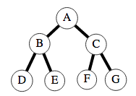
The parent Dictionary for this Graph would have the following items:
Key | Value
B | A
D | B
E | B
C | A
F | C
G | C
The parent of B is A, the parent of D is B, and so on. Note that there is no entry for the A key, as it is the root node (it does not have any ancestor nodes).

Checking for Back Edges
We will now modify the stack of blocks you duplicated earlier to check for back edges. This duplicated stack of blocks can now be placed after the is subgraph of colour edges connected block.
First, create a variable called parent by following the steps you completed in previous parts of this activity. This variable will be used for the Dictionary that keeps track of nodes' parents.
Add the following block after the set to visit to block, which will set the parent variable to an empty Dictionary:
Next, we want to add a block that adds an item to the parent Dictionary, to keep track of each of the visited node's parents. We have to do this at the same time as we push the current node's neighbours onto the to visit Stack. We want to add a block that adds this item within the if block that checks if the neighbour has been visited, as shown in the image below:
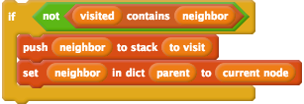
For example, if the current node is A and that node is neighbours with the node B, then an item with the key: B and value: A will be added to the parent Dictionary. After clicking the green flag, you will see that the nodes connected by red edges will be keys in the parent variable's Stage Monitor.
Now, we are going to add blocks to check for a back edge. Firstly, right click the if block that you just modified, click relabel... and select the first option (which changes the if block to an if else block). In the else section of the if else block we are going to add another if block that looks at the neighbours that the depth-first search has already visited and see if their parent is one of the current node's ancestors. The following if block goes inside the else section of the if else block, as shown below. Note that you can find the report block in the Control section and the true block in the Operators section.
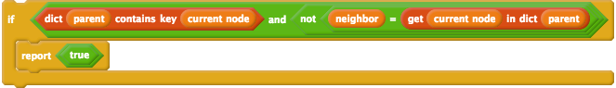
There are some important parts about the blocks above to highlight. Firstly, there is a check in the if block that the parent Dictionary contains an item for the neighbour. This check is there because a neighbour that has been visited and is not in the parent Dictionary, is the root node. The root node will have no ancestors and consequently we do not need to check what its parent is. As both of these checks in the if block are in an and block, the second check will only be followed if neighbour is not the root node.
If the neighbour is not the root node, then we check if the neighbour has been marked as the Current Node's parent. If the Current Node already has another parent recorded in the parent Dictionary and it is not the neigbour then we know that there is a back edge.

For example, if we had the Graph and variables shown below, the blocks above would find the back edge from the Neighbour node to the Ancestor node.
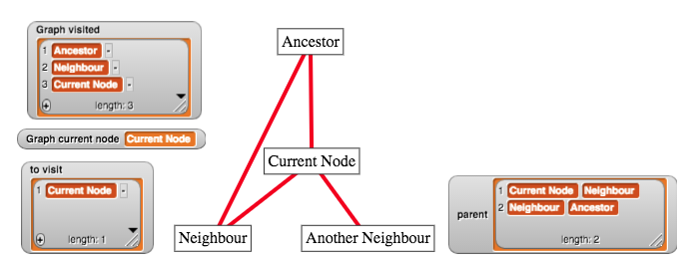
Note that in the image above, the Current Node node is currently being visited, and that the Neighbour node is in the visited List. Additionally, the value of the item with the key Current Node in the parent Dictionary is not Ancestor, it is Neighbour. Consequently, the report true block would be followed, indicating that the Graph is cyclic.
It is also important to note that when a report block is followed, it will report a value and then stop following the rest of the blocks in that stack. Therefore, if we reach the end of the stack of blocks without the report true block being followed, then we know there is no cycle in the Graph. To indicate that there is no cycle in the Graph, you can replace the report block you previously had at the bottom of the stack of blocks with the following block:
Note that the false block comes from the Operators section of the Blocks Palette. To make the false block, click the grey circle next to the true block, as highlighted in blue in the image below:
Lastly, we have to consider the case where the node we start from (A) is not connected to the other nodes in the Graph. For example, if we created the Graph shown below, our blocks would not report that it has found a cycle because A has no neighbours and would not visit any of the other nodes in the Graph.
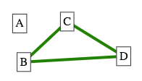
Consequently, we have to change our algorithm to make sure every node is visited. To do this, you will have to take a for each item block and wrap it around the stack of blocks, starting from after the set visited to block and ending before the second report block. Next, click the item name in the for each item block and change it to node instead. After doing that, you will also have to change the block that pushes the first node onto the to visit stack to this instead:
The final stack of blocks that implements this features is available on the solutions page of the workshop website, for you to compare your own stack of blocks against.
Now when you click the green flag, you should see a speech bubble appear with true or false, depending on whether the Sub-Graph with red edges contains a cycle or not.

Creating a Custom Block
You should now move the blocks that you have created for checking whether a Sub-Graph of certain coloured edges into a custom block. Follow the same steps that you followed to create the is subgraph of colour edges connected block, but name the block is subgraph of colour edges cyclic instead. When you have the Block Editor open, drag the blocks that you created for checking for a back edge in a Graph underneath the is subgraph of colour edges cyclic hat block. This block will also have an input called colour, which should be used in the if block that checks the colour of the edge.
Next, place your newly created is subgraph of colour edges cyclic block in a say block and place it at the end of your main stack of blocks, after the is subgraph of colour edges connected block. After creating that custom block and placing it in a say block in your main stack of blocks, your blocks should look similar to those in the image below:
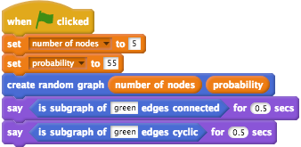
Now, if you click on the stack of blocks different random Graphs will be created and a speech bubble will appear. The first message will indicate whether the Sub-Graph of green edges is connected and the second message will indicate whether the Sub-Graph of green edges is cyclic.

Conclusion
You have finished the Creating Networks in Edgy Activity. Good work!
The blocks that you have made in this activity (the is subgraph with edges coloured? and is subgraph with edges coloured cylic? blocks), will be used in the next activity, where you create algorithms in Edgy to find a Graph's Minimum Spanning Tree.

You have learned about the following Networks concepts in this activity:
- Graphs and Subgraphs
- Complete Simple Graphs
- Random Graphs
- Connected Graphs
- Cyclic Graph
And you also applied some Coding concepts that you learned about in the Coding in Snap! Activity, including:
- Sequencing
- Repetition
- Variables
- Functions
- Branching
- Lists
If you are interested in learning more about Edgy, we have included some links to some resources for learning Edgy on the workshop website, on the page for this session (Creating Networks in Edgy).

